**The Gripper Base**

Z points along gripper

Y points up towards knob on UR5

X points along rail

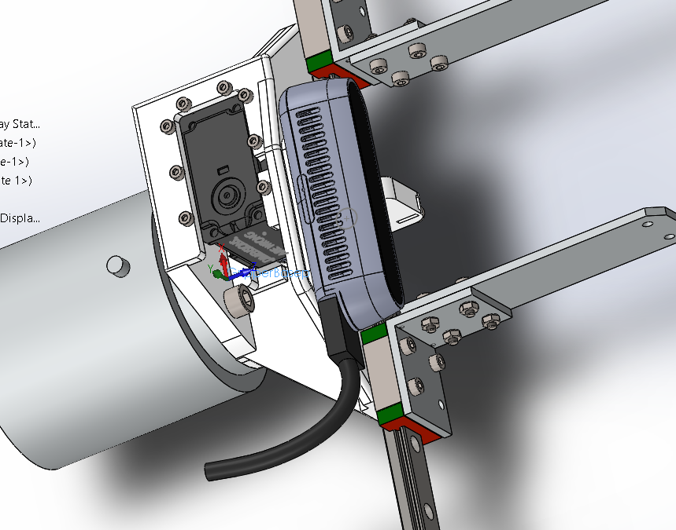

**The D435 Tripod Mount**

Z points out with D435

Y points up towards top of camera

X points along camera

10 degree tilt from vertical

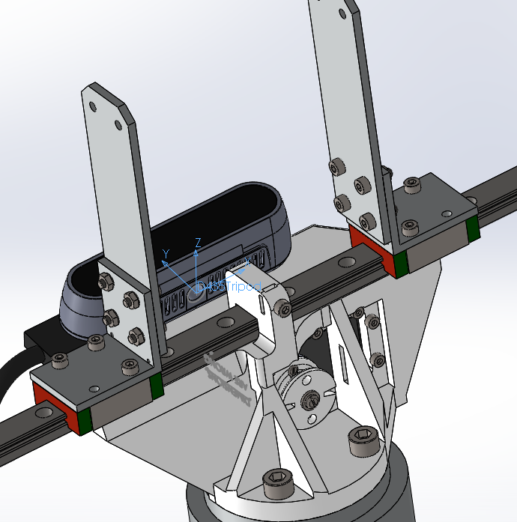

**Grip Point**

20mm down from tip of fingers

Z points out along gripper

Y points up

X points along rail

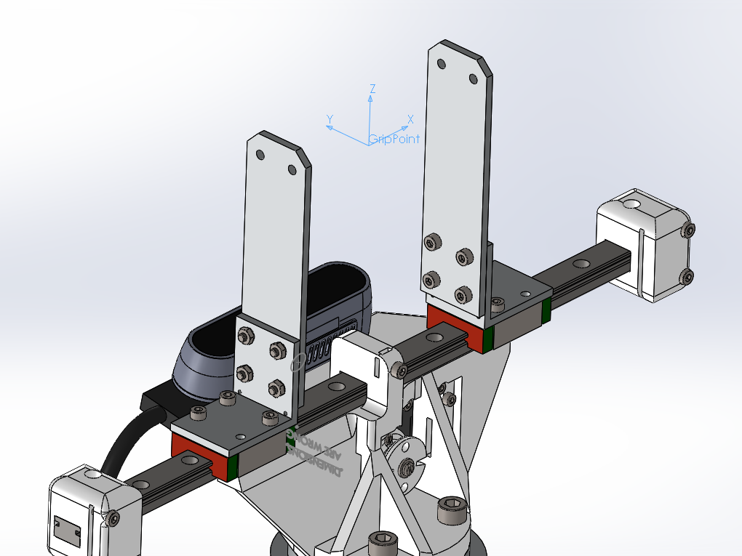

Base to D435

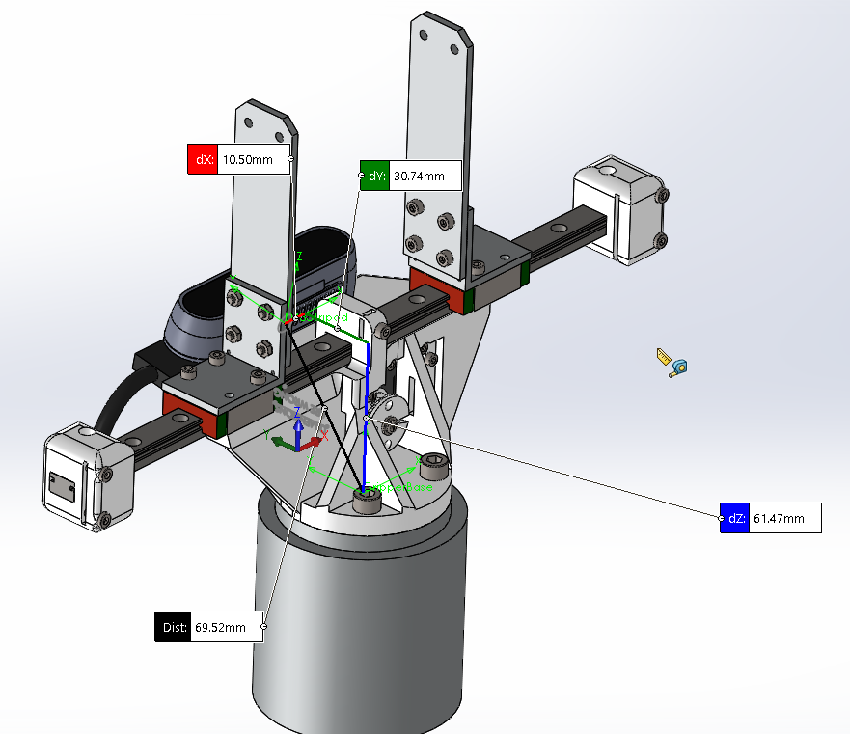

Base to Gripper

